**Welcome to our service!**

We support breastfeeding & infant feeding practices

**Here are some of the ways that we support breastfeeding & infant nutrition,**

**so your child can enjoy healthy foods in a supportive mealtime setting.**

**We support breastfeeding and the use of expressed breastmilk**



* We welcome you to drop-in to feed your child in our comfortable, private space.
* We follow guidelines to make sure expressed breastmilk is safely handled.
* We provide a daily update of your child’s feeds.

**We support starting solids at around 6 months of age**

* We will support you when you start to provide solid foods to your child. We can help you and your child as they move from eating pureed to minced foods, then onto finger foods.
* We can help you with a range of healthy food ideas for your child that suit their age.
* We provide feedback to you about your child’s food and drink intake as well as their progress with feeding themselves.

**Our menu offers healthy foods**

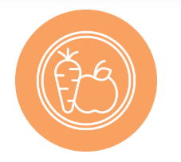**n**

* We provide fresh, healthy meals and snacks to children each day. These are based on the 5 food groups from the Australian Dietary Guidelines.

**Our educators respond to children’s needs during feeding times”times**

* We sit with children during meals and role model healthy eating to create a pleasant, social setting.
* We create calm mealtimes so that your child can focus on tasting and eating foods.
* We look for signs that a child is hungry or full, to meet their needs.