Infants Corner:
Recommended foods for under 2’s

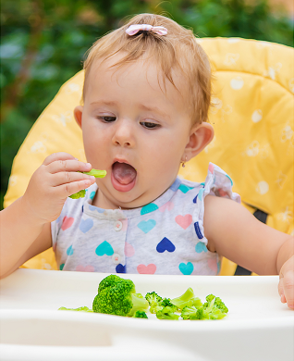
Infancy is a time of rapid growth & development and children’s nutritional needs & appetite will change over this period. The Australian Dietary Guidelines provides a guide around how much & what type of foods to provide growing children. To meet their nutritional needs, it’s recommended to provide children with a variety of foods from the five food groups. Click here for a guide around recommended amounts of food to offer children.

Its important to remember to use this information as a guide only as it’s normal for children to eat different amounts from one day to the next.

When children are spending a day in childcare, it’s recommended that they’re provided with around half of their recommended food intake for the day during these hours. For example, it’s recommended that toddlers are provided with 1-2 serves of vegetables whilst in care depending on their age.

Our service aims to meet these recommendations and provide a variety of tasty & nutritious foods. Vegetables are often included in the main dish as well as being served as a side or as part of snacks. Our menu is on display for more information. We often find children are willing to try different foods at care than at home. Chat to our educators or view your child’s feeding update to find out about what foods your child has been enjoying at care.

If you’re looking for recipe inspiration, including vegetable packed options, check out the Good for Kids website here.

