Breastfeeding Support Plan
Note: This breastfeeding support plan template has been provided to assist early childhood education and care services to support families that choose to continue to breastfeed their infants while in care. Customise this template to suit your service context and to best support the families at your service. Involve staff and families in the development of their breastfeeding support plan and review together regularly to ensure that the support plan remains current and suitable to meet the needs of the infant. It is important that your service policies and procedures for transporting and storing expressed breastmilk are communicated to families.

Our service would like to support you should you decide to continue breastfeeding. Please complete this plan to help us support you and your infant.
Child’s Name:_______________________________________________________________________
Mother’s Name:____________________________Mother’s contact number:___________________
- Has your infant ever taken expressed breastmilk before? (Please tick) Yes No

- How does your infant feed at home? (Please tick and add comments)
Exclusively from the breast Expressed breastmilk Infant formula
Breastmilk supplemented with infant formula
Comments: ______________________________________________________________________________________________________________________________________________________________________________________________________________________________________________________

- How often does your infant feed each day? This might include on demand, before or after mealtimes (e.g. breakfast, lunch, dinner) or to go to sleep.
______________________________________________________________________________________________________________________________________________________________________________________________________________________________________________________

- How would you like your infant to be fed while at our service? (Please tick and add comments)
Feed your expressed breastmilk You visit the service to breastfeed
You breastfeed before departure and on pick up Feed infant formula
Comments: ______________________________________________________________________________________________________________________________________________________________________________________________________________________________________________________

- If you would like to visit your infant to feed, how can we support you? This might include arranging to visit at pre-specified times, or phoning you when your infant is showing hunger signs.
______________________________________________________________________________________________________________________________________________________________________________________________________________________________________________________

- If the supply of expressed breastmilk runs out before you are due to return, what actions would you like us to take? This might include making contact with you, offering infant formula, or for children over 12 months of age offering cow’s milk.
______________________________________________________________________________________________________________________________________________________________________________________________________________________________________________________
- Does your infant have a preference for a type of bottle or cup to feed from? (please tick and add comments)
A sippy cup An open cup A wide teat bottle A narrow teat bottle
Comments:
______________________________________________________________________________________________________________________________________________________________________________________________________________________________________________________
8. Can you share any settling techniques or routines that help your infant settle and sleep? Many breastfed infants breastfeed to go to sleep. Does you infant settle with other techniques or routines? This may include the use of a special blanket or another source of comfort or activity.
________________________________________________________________________________________________________________________________________________________________________________________________________________________________________________________________________________________________________________________________________
9. What else can we do to support you to continue breastfeeding?
______________________________________________________________________________________________________________________________________________________________________________________________________________________________________________________________________________________________________________________________________________________________________________________________________________________________________________________________________________________________________________________________________________________________________________________________

Please review this plan if there are any changes to your routine.

Date of last review: ________________________

Note for services
Length of time expressed breastmilk can be stored
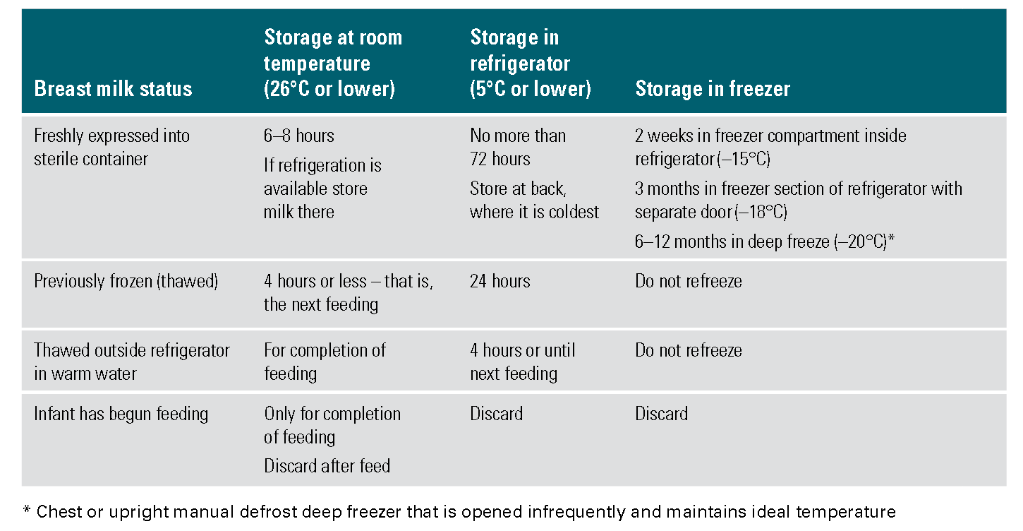
Source: National Health and Medical Research Council (2012) Infant Feeding Guidelines. Canberra: National Health and Medical Research Council.
Resources
For further information:
- Early Childhood Health Centres: For centre locations throughout NSW, consult your local white/yellow pages or whitepages.com.au under the heading ‘Community Health Centre’ or ‘Early Childhood Health Centre’.
- Australian Breastfeeding Association (ABA): Breastfeeding Helpline 1800 686 268 www.breastfeeding.asn.au
- Tresillian 24-hour Parents Helpline: (02) 9787 0855 or 1300 272 736 (freecall outside Sydney metropolitan area) www.tresillian.net
- Karitane Care Line: 1300 227 464 www.karitane.org.au
- Mothersafe. Medications in Pregnancy and Lactation Service: Phone: (02) 9382 6539 or 1800 647 848 (freecall outside Sydney metropolitan area)
- Personal Health Record (known as the ‘Blue Book’): www.health.nsw.gov.au
- Healthy Kids website: www.healthykids.nsw.gov.au
- Infant Feeding Guidelines: www.eatforhealth.gov.au
- Raising Children Network: www.raisingchildren.net.au

Brochures
- Giving Your Baby the Best Start: www.eatforhealth.gov.au/sites/default/files/files/the_guidelines/n55e_infant_brochure.pdf
- Starting Family Foods: www.healthykids.nsw.gov.au/downloads/file/teacherschildcare/NSWHealth12ppDLbrochure_Sept15_WEBSINGLEPAGESsmaller.pdf
- Get Up & Grow – Breastfeeding and returning to work www.health.gov.au/internet/main/publishing.nsf/content/phd-gug-hw06
- Get Up & Grow – Breastfeeding (Aboriginal and Torres Strait Islander specific)
www.health.gov.au/internet/main/publishing.nsf/content/B941913A986BC5E2CA257BF0001A8E47/$File/Brochure%20-%20Breastfeeding.pdf

