(Insert early childhood education and care service name) Breastfeeding Policy (Procedure/Guideline)
Note: This sample breastfeeding policy (procedure/guideline) has been provided to assist early childhood education and care services to develop their own breastfeeding policy (procedure/guideline). Tailor the information in this sample policy (procedure/guideline) to suit your particular service– delete sections that are not relevant to your service and add additional points that reflect your practice. Involve staff and families in the policy (procedure/guideline) development and review process. Ensure that the final policy (procedure/guideline) is on display and accessible to all staff and families.
Rationale
Breastmilk is the ideal food for infants as it contains essential nutrients, protects them from illness, and provides many other long-term health benefits for both mother and infant. Exclusive breastfeeding provides ideal nutrition and is sufficient to support optimal growth and development for the first 6 months of life. Introduction of solid foods from around 6 months of age should complement the breastmilk diet¹. Continued breastfeeding is recommended throughout the first year and beyond as long as mutually desired by mother and infant². Any breastfeeding is considered beneficial for the infant and mother.
While Australia’s breastfeeding initiation rate is 96%², only a small proportion of women achieve the goal of exclusively breastfeeding to around 6 months². Exclusive breastfeeding means that the infant only receives breastmilk without any additional food or drink¹.
Mothers are encouraged to continue breastfeeding if they return to work. The early childhood education and care environment is a key setting for the promotion and support of breastfeeding. The role of educators to support breastfeeding is important to further increase Australia’s breastfeeding duration rates.
It is important to follow correct procedures to ensure safe food handling and hygiene when using expressed breastmilk. Where infants are not breastfed or are partially breastfed, a commercial infant formula should be used as an alternative to breastmilk until 12 months of age.
Service Commitment
(Insert early childhood education and care service name) will encourage and support all families to continue breastfeeding their infant until at least 12 months of age, in line with current recommendations.
Our service recognises that families have the right to decide whether they will breastfeed their infant while they are in care, and each family’s decision will be accepted and respected.
Our service will provide a supportive environment by feeding infants expressed breastmilk supplied by their families and by providing suitable spaces and resources to mothers breastfeeding their infants at the service.
Relevant Legislation
National Quality Framework

National Quality Standard
Standard 2.1 – Each child’s health and physical activity is supported and promoted.
Elements 2.1.1, 2.1.2, 2.1.3
Element 5.1.2.
Elements 6.1.2, 6.1.3

Early Years Learning Framework
Learning Outcome 1 – Children feel safe, secure and supported. Children develop knowledgeable and confident self-identities.
Learning Outcome 3 – Children become strong in their social and emotional wellbeing. Children take increasing responsibility for their own health and physical wellbeing.

Legal Requirements
Our service recognises that the right to breastfeed is protected under federal and state legislation, and we will meet our legal obligations.

The service will NOT:
- Refuse an application for a childcare place, or not offer a place, because a child is breastfed, as required by law.
- Discourage a mother from continuing to breastfeed when her child starts in care.
- Refuse to let a mother breastfeed or express breastmilk on the premises.
- Refuse to feed a child its mother’s expressed breastmilk.
- Do anything else that makes it difficult for families to continue giving breastmilk to a child while they are in the service’s care.
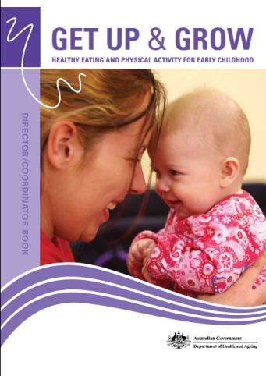
Healthy Eating Guidelines
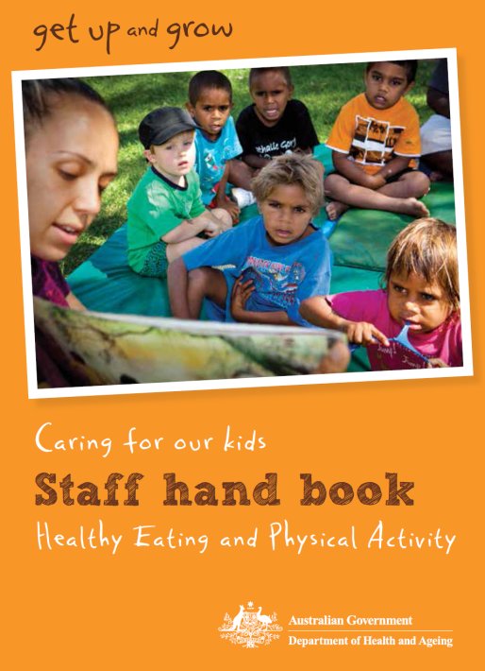
- Exclusive breastfeeding is recommended, with positive support, for infants until around six months. Continued breastfeeding is recommended for at least 12 months – and longer if the mother and baby wish.
- If an infant is not breastfed, is partially breastfed, or if breastfeeding is discontinued, use an infant formula until 12 months of age.
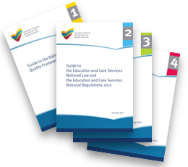

Key Resources
- NSW Health Munch & Move program resources available on the Healthy Kids website www.healthykids.nsw.gov.au
- Caring for Children: Birth to 5 years (Food, Nutrition and Learning Experiences), NSW Ministry of Health, 2014.
- Infant Feeding Guidelines, 2012, www.eatforhealth.gov.au
- Australian Dietary Guidelines, 2013, www.eatforhealth.gov.au
- Staying Healthy: Preventing infectious diseases in early childhood education and care services (5th edition), 2013.

The policy (procedure/guideline) aims to:
- Provide a supportive breastfeeding environment
- Encourage communication at initial contact and orientation
- Provide safe feeding and handling of expressed breastmilk
- Provide staff training
- Support staff members who are breastfeeding

Our strategies to implementing this policy (procedure/guideline) include:
- Provide a supportive breastfeeding environment
- Provide mothers with a private, clean and quiet place to breastfeed their infants or express breastmilk. The place will include an electrical outlet, comfortable chair, a change table and nearby access to hand washing facilities.
- Provide refrigerator space for breastfeeding mothers to store their expressed breastmilk.
- Educate staff and families that a mother may breastfeed her infant wherever they have a legal right to.
- Develop a documented individual breastfeeding support plan in consultation with family members for breastfed infants.
- Offer information on the benefits of breastfeeding to all families enrolled at the service.
- Display easily accessible brochures, pamphlets and other resources about breastfeeding.
- Maintain current printed or electronic lactation resources available to families and staff.
- Display culturally appropriate pictures and posters of breastfeeding and exclude those supplied by formula manufacturers.
- Include fathers in the discussions about breastfeeding.
- Stimulate participatory learning experiences with the children related to breastfeeding and offer children’s books that contain pictures of breastfeeding, play dolls that are nursing and other learning experiences that normalise breastfeeding.
- Establish and maintain connections with local breastfeeding support networks, including NSW Health and the Australian Breastfeeding Association.
- Refer mothers with breastfeeding concerns to appropriate resources, including support services offered by NSW Health, Australian Breastfeeding Association groups or private lactation consultants.

- Encourage communication at initial contact and orientation
- Ask families about breastfeeding at the time of enrolment.
- Inform expectant and new families and visitors about the service’s breastfeeding friendly policies.
- Ensure all staff are able to explain the benefits of exclusive breastfeeding till an infant is 6 months of age and offer this information to families.
- Include breastfeeding policy and practice materials in the service’s information and orientation package, including information on transporting and storing expressed breastmilk.
- Allow current and prospective families to drop in and view the breastfeeding friendly environment.
- Develop a documented individual breastfeeding support plan in consultation with family members, including arrangements for what the service should do if the service does not have enough expressed breastmilk to meet the infant’s needs.
- Work with families to familiarise the infant with bottle feedings of expressed breastmilk and/or infant formula prior to starting care.

- Provide safe feeding and handling of expressed breastmilk
- Require families to label their own expressed breastmilk with their child’s name, date and time expressed. If thawed, milk will also be labelled with the date and time thawed (see Appendices 1 & 2).
- Store expressed breastmilk in a designated space within the refrigerator and freezer.
- Not exceed the maximum storage times outlined in the Australian Infant Feeding Guidelines (see Appendix 2).
- Enable infants to build a secure attachment with one and then more familiar educators by ensuring infants are fed on demand and always held during feedings.
- Use the procedure outlined in Appendix 1 for feeding expressed breastmilk to infants.
- Where expressed breastmilk is provided in a container larger than a single serving, limit wastage of expressed breastmilk by initially filling the bottle with less milk than may be necessary for the feeding, with additional milk available to add to the bottle if needed.
- Use a cup or spoon for feeding, where an infant will not accept a bottle.
- In consultation with the family, avoid feeding a breastfed infant right before the mother arrives to pick up her child, as this is an ideal time for the mother to nurse and will help the mother keep a good milk supply.
- In the event that an infant is fed another child’s bottle of expressed breastmilk, treat the incident as an accidental exposure to a bodily fluid. An incident report will be completed and both affected families informed (see Appendix 1).

- Provide staff training
- Provide orientation for new staff to the breastfeeding policy and offer appropriate training, including using a cup or spoon for feeding, where an infant will not accept a bottle.
- Ensure all staff that have responsibility for care of infants are able to provide basic breastfeeding information and are able to refer mothers with breastfeeding concerns to appropriate resources, including support services offered by NSW Health, Australian Breastfeeding Association groups or private lactation consultants.
- Ensure staff encourage families to develop infant’s individual breastfeeding support plans and regularly update their plans.
- Ensure all staff promote exclusive breastfeeding until infants are around 6 months old with continued breastfeeding until 12 months and beyond.

- Support staff members who are breastfeeding
- Treat requests for support to continue breastfeeding sympathetically and reasonably, and make all reasonable efforts to support the staff member.
- Provide breastfeeding staff with a flexible schedule for breastfeeding or pumping to provide expressed breastmilk for their infant.
- Provide breastfeeding staff with a private, clean and quiet place to breastfeed their infant or express breastmilk. The place will include an electrical outlet, comfortable chair, a change table and nearby access to hand washing facilities.

Monitoring and Review
- Report on breastfeeding goals and achievements in the service’s Quality Improvement Plan (QIP) where appropriate, annual reports or management committee meetings.
- Review the Breastfeeding Policy every (insert timeframe for review).
- Provide families with opportunities to contribute to the review of this policy (procedure/guideline).
Appendix 1

Expressed Breastmilk Procedure

- Expressed breastmilk will be brought to the service in a clean, sterile container, labelled with the date and time of expression and the child’s name. If thawed, milk will also be labelled with date and time of thawing.
- The expressed breastmilk will be stored at 4°C or lower until it is required.
- The educator will confirm the child’s name and date of expression on the container, and the amount to be prepared, with another educator. This should be noted on the infant’s record.
- To limit wastage where expressed breastmilk is provided in a container larger than a single serving, the bottle is initially filled with less milk than may be necessary for the feeding, with additional milk available to add to the bottle if needed.
- The expressed breastmilk will be warmed and/or thawed by running the container under warm water or by standing the container in warm water. Never reheat expressed breastmilk in a microwave.
- An educator will test the temperature of the expressed breastmilk by placing a few drops on the inside of their wrist before the expressed breastmilk is given to the infant.
- Discard the contents of any bottle not fully consumed in one hour from the start of the feed.
- If there is not enough expressed breastmilk to meet the infant’s needs, the educator will consult with the infant’s individual breastfeeding support plan, or the infant’s family.
- Unused milk not warmed or thawed will be returned to families at the end of the day to avoid confusion and to ensure that expressed breastmilk is used within 48 hours of expression or thawing.
- In the event that an infant is fed another infant’s bottle of expressed breastmilk, treat the incident as an accidental exposure to a bodily fluid. An incident report will be completed and both affected families informed.
Appendix 2
Length of Time Expressed Breastmilk Can Be Stored

Breastmilk status | Storage at room temperature (26°C or lower) | Storage in refrigerator  (5°C or lower) | Storage in freezer
Freshly expressed into sterile container | 6-8 hours  If refrigeration is available store milk there | No more than 72 hours  Store at back, where it is coldest | 2 weeks in freezer compartment inside refrigerator (-15°C)  3 months in freezer section of refrigerator with separate door  (-18°C)  6-12 months in deep freeze  (-20°C)*
Previously frozen (thawed in refrigerator) | 4 hours or less – that is, the next feeding | 24 hours | Do not refreeze
Thawed outside refrigerator in warm water | For completion of feeding | 4 hours or until next feeding | Do not refreeze
Infant has begun feeding | Only for completion of feeding  Discard after feed | Discard | Discard

* Chest or upright manual defrost deep freezer that is opened infrequently and maintains ideal temperature
Source: NHMRC (National Health and Medical Research Council), 2013, Infant Feeding Guidelines, National Health and Medical Research Council, Canberra

Commonwealth of Australia, 2009, Get Up & Grow: Healthy Eating and Physical Activity Guidelines for Early Childhood, Department of Health and Ageing, Canberra
NHMRC (National Health and Medical Research Council), 2013, Infant Feeding Guidelines, National Health and Medical Research Council, Canberra
NHMRC (National Health and Medical Research Council), 2013, Infant Feeding Guidelines, National Health and Medical Research Council, Canberra

