News snippets to share with your families
Below is a collection of news snippets which can be used to inform families about the initiative to increase outdoor free play at your service. Include these snippets in your regular communications with families such as newsletters, social media posts or on an alternate platform such as story park.
These snippets will inform your families about the benefits of increasing outdoor free play and build their understanding and support for the initiative.
You may use each snippet as formatted in the table below on the right, or create a new snippet using the text and images provided. To use the Formatted snippet, click on the image and Save As a picture file before uploading it onto your chosen platform.
Recommended use | Text only | Image | Formatted snippet  (Ctrl + Click on the image to access)
1st snippet  Introduces the initiative to your families.  Prior to sharing with families, please ensure your staff are aware of this initiative at your service . | Getting Outside and Getting Active  We are working with the Good for Kids, Good for Life team at Hunter New England Health, to help kids be more active.  We will be offering "indoor-outdoor free play" sessions, where children can move between indoor and outdoor areas during playtime, giving them more opportunities to play outside.  This type of play is linked to increased physical activity and is recommended by national guidelines for Early Childhood services.  Please ensure your child is dressed appropriately for the weather and for lots of fun and learning in the outdoors! | 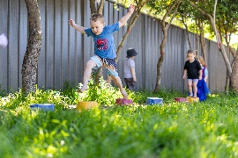 | 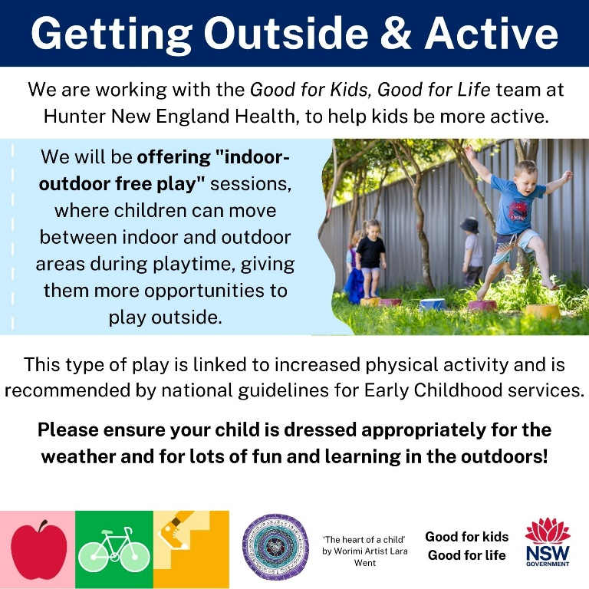

Recommended use | Text only |  | Image | Formatted snippet  (Ctrl + Click on the image to access)
2nd snippet  Advises families of the benefits of outdoor play for their child. |  | Benefits of outdoor play  Children spend much less time outdoors than past generations, but outdoor play offers many benefits as they grow:  Physical development: Outdoor play encourages kids to be more active, helping build strength, coordination, and fitness.  Social development - Kids interact more with others, improving social skills like cooperation, negotiation, and conflict resolution.  Emotional development: Outdoor play helps children assess risks, building independence, resilience, and confidence.  Cognitive development: Playing outside enhances learning, communication, focus, problem-solving, and  creativity.  Regular time outdoors is essential for your child’s health and wellbeing – it also boosts school readiness.  Our service is increasing opportunities for children to play outside. | 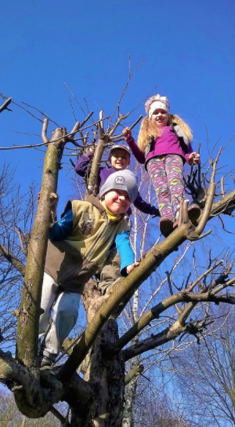 | 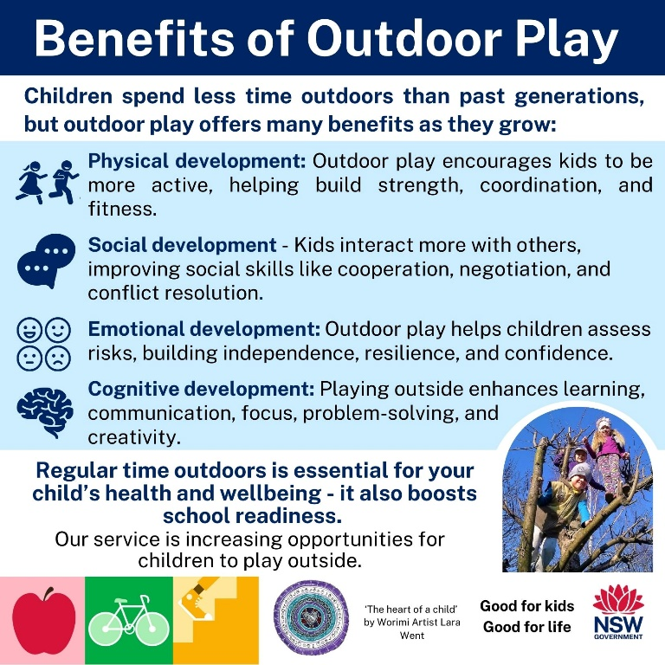

Recommended use | Text only | Image | Formatted snippet  (Ctrl + Click on the image to access)
3rd snippet  Encourages families to engage in outdoor play with their child at home. | Encouraging outdoor play at home  - Lead by Example: Kids are more likely to join in if they see you having fun outside. Playing games and sports together makes it more fun and helps strengthen your bond with your child  - Create a Safe and Interesting Outdoor Space: Offer age-appropriate equipment such as balls, bicycles, swings, or climbing structures. Consider natural elements like plants, sandboxes, or water play areas.  - Set a Routine: Schedule regular outdoor playtime in your child’s day to help build good habits.  - Limit Screen Time: Encourage your child to play outside instead.  - Promote Exploration: Take nature walks, visit gardens, or explore parks. Let your child choose and encourage them to ask questions about what they see.  Encourage a love for outdoor play to support your child’s physical, mental, and social growth. | 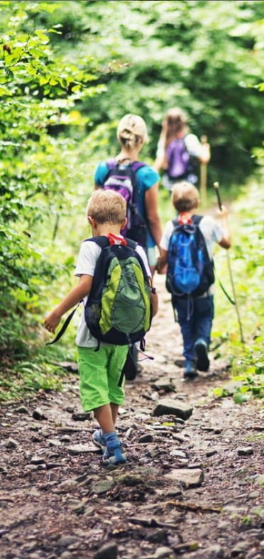 | 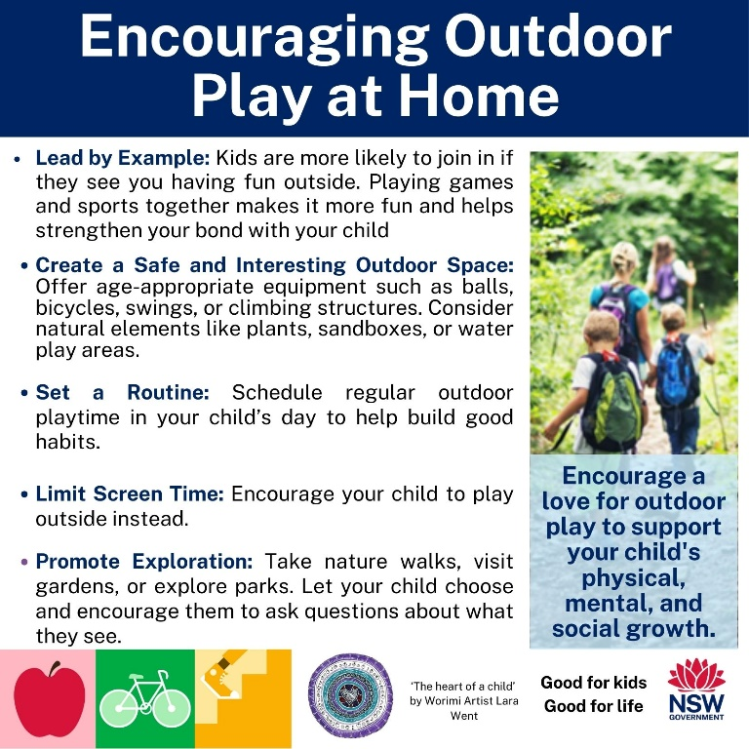

Recommended use | Text only | Image | Formatted snippet  (Ctrl + Click on the image to access)
4th snippet  Encourages families to bring indoor activities with their child over to the outdoors. | Moving the indoors, outdoors!  To offer children more opportunities for active outdoor play, we have been moving the indoors to the outdoors!  Why not consider which games, toys and activities at your home, could be moved to the outdoors?  Here are some ideas:  Art – bring the easel or table outside and remove chairs to allow your child to stand and move around while creating their masterpiece.  Toy cars and trucks - draw tracks for vehicles by using chalk on hard surfaces or build a track using natural materials.  Dolls - Use a pram outside to take the dolls for a walk and a picnic in the backyard.  Looking for more ideas to promote outdoor play?  Search here and online:  www.bunnings.com.au/diy-advice/kids-craft/games-toys  Encourage your child’s creativity by allowing them to lead the play and come up with their own games.  Then join them in the fun! | 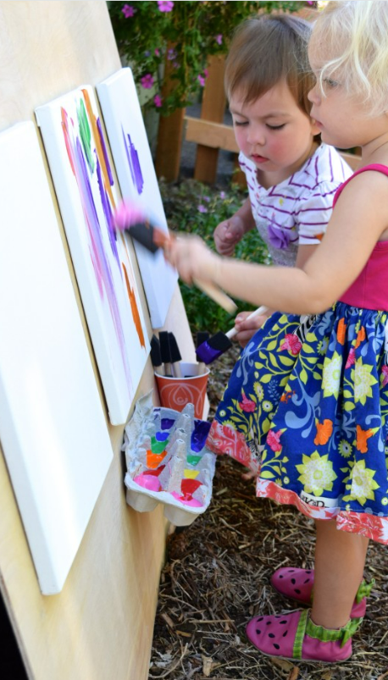 | 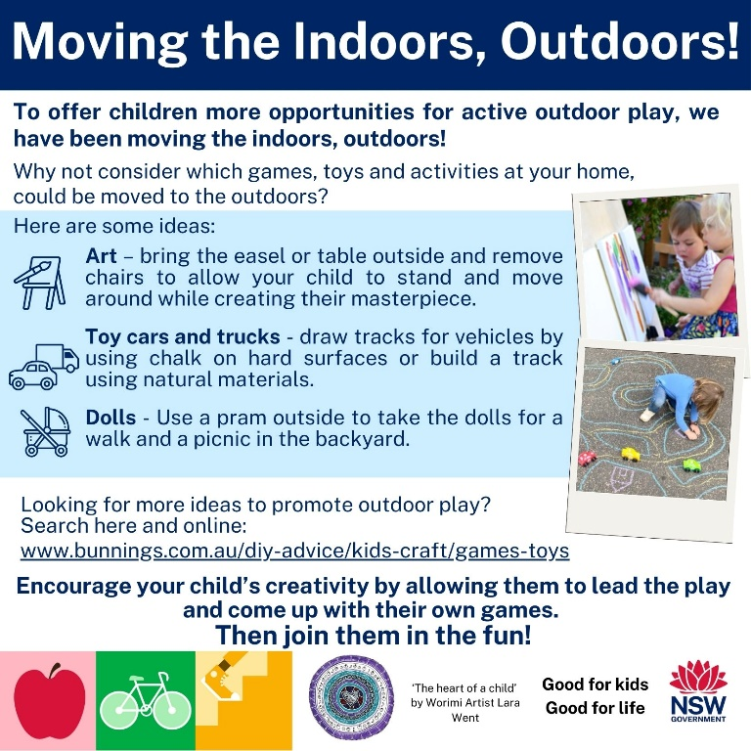

Recommended use | Text only | Image | Formatted snippet  (Ctrl + Click on the image to access)
Winter snippet  Encourages families to promote outdoor play on cold/wet days. | Getting Out in the cold & rain  Motivating children to play outside when it's cold, wet or windy can be a challenge, but it is certainly worthwhile and usually loads of fun!  Dress for the challenge - put on raincoats and gumboots and get outside! Consider a beanie and gloves for colder days, and a change of clothes after a wet or muddy outdoor adventure.  Make it fun - jump over puddles, look for snails & worms in the garden or sail paper boats & leaves in pools of rain.  Use undercover areas - make use of verandas and shelters that provide cover from the rain.  Create warmth - physical activity is a great way to warm up! Encourage your child to jump ten times over a stick, jog on the spot for a few seconds or have an outside dance party to create some heat.  "There's no such thing as bad weather, just bad clothing!" | 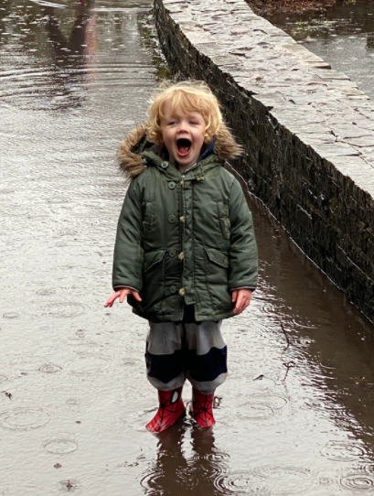 | 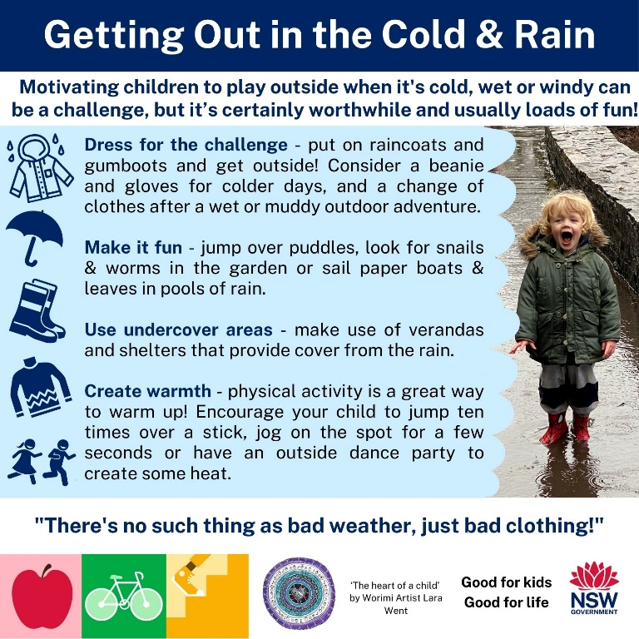

Recommended use | Text only | Image | Formatted snippet  (Ctrl + Click on the image to access)
Summer snippet  Encourages families to promote outdoor play on hot days. | Getting outside on hot days  Encouraging children to play outside when the weather is hot can be a challenge. While it’s essential to ensure children are protected from the sun, it is still important to encourage children to spend time outdoors.  - Low UV-index - encourage your child to play outside when the sun's UV rays are weakest, in the early morning or late afternoon.  - Seek shade - play games like hopscotch or handball in the shade, or take a walk through a shady park or reserve.  - Water-play - if water restrictions are not in place, allow your child to run through sprinklers, use a water play table or spray bottles for some squirt-fun!  - Slip, slop, slap, sip, sit - ensure your child has sunscreen, sun-smart clothing and a hat. Water and rest breaks should be frequent to avoid overheating.  Plan your time outside, be SunSmart* and stay hydrated.  *www.cancer.org.au/cancer-information/causes-and-prevention/sun-safety/be-sunsmart | 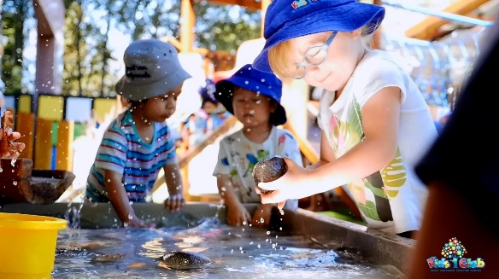 | 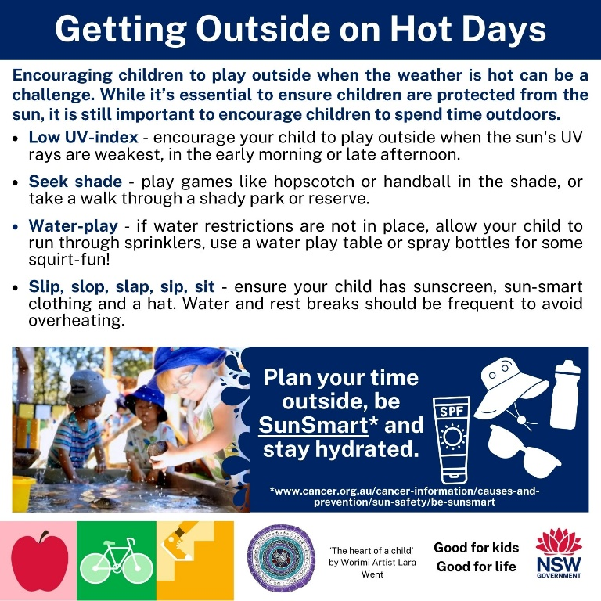

Recommended use | Text only | Image
Final snippet  Use to share with families, the experience of your service in the GOGA program.  *Please note this snippet needs to be completed by adding your observations of the GGA program at your service in Microsoft Word before uploading as a social media post | Getting Outside and Getting Active – Reflections  Over the past 6 months, our service has used indoor-outdoor free play as a way of increasing physical activity.  Suggested text to insert:  Some of the benefits we have seen within the service include<insert description here>  We have found that the children reacted to the indoor-outdoor free play program by <insert description here>  Some of the other changes we noticed were <insert description here>  When we asked the children what they liked about being outdoors they said <insert description here> |  | 