5j

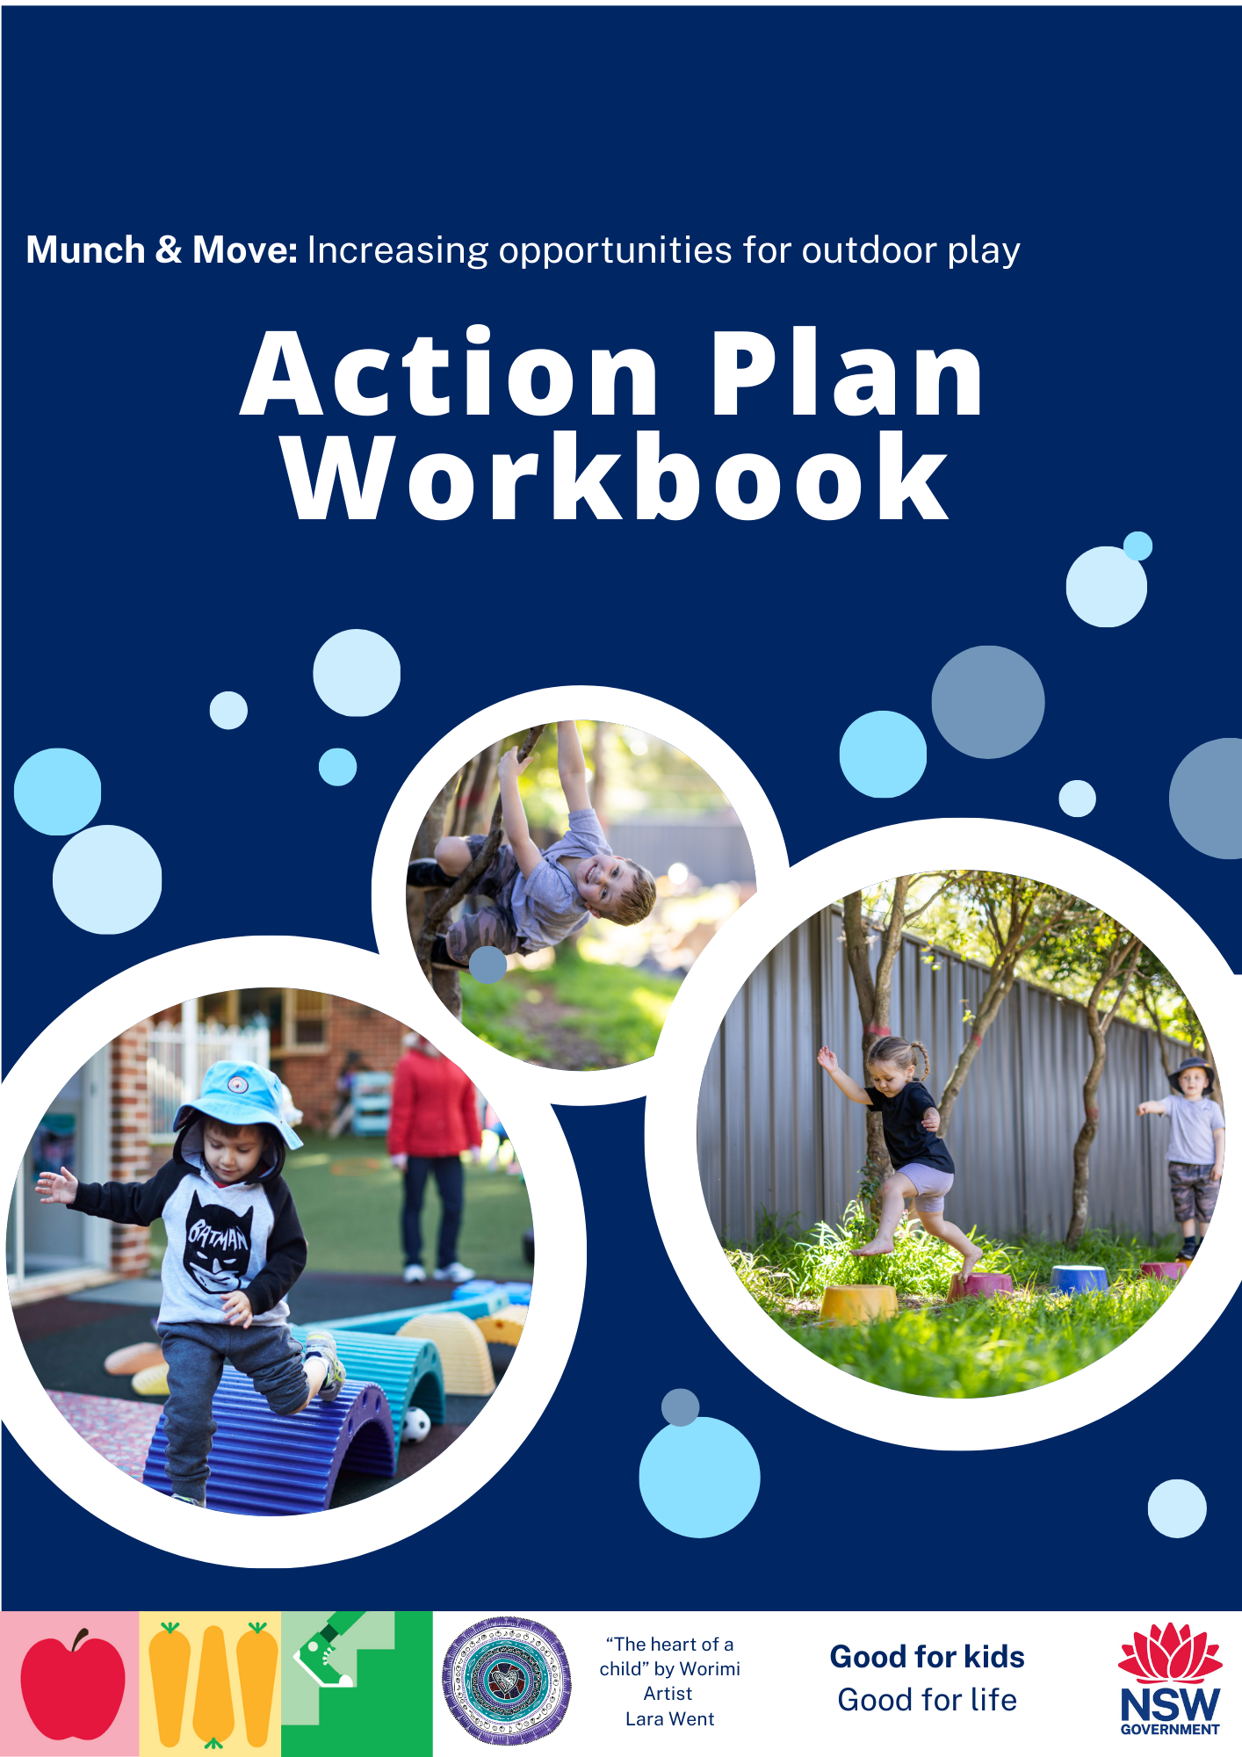

**Welcome to your Action Plan Workbook!**

This workbook is designed to support your service to implement indoor-outdoor free play by inspiring and guiding you to reflect on your current practice and develop an action plan for change.

Here are the recommended steps to take when using this workbook:

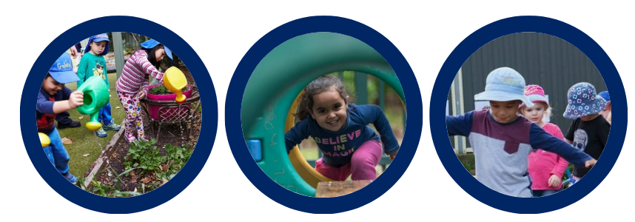

Step 1.

|  |
| --- |
| **a. Why is it important for our service to increase opportunities for outdoor free play?**  *For example, helping children develop into the best they can be, setting children up for a long and healthy life, having a positive impact on the health and care of children, and reduced spread of colds and flu. You may also want to think about how this aligns with your service philosophy and policies.* |
| **b. What outcomes or benefits do we hope to see?**  *For example, increased physical activity levels, building resilience, greater immunity, increased concentration, increased learning opportunities, social interactions, connection with nature, connection with country. You may also like to consider benefits at the Educator, service, or family level as well as those at the child level.* |

**Step 1: Reflective Questions**

**c.** **Identifying opportunities to increase outdoor free play**

Changing your service’s *indoor-only* free play sessions to *indoor-outdoor* free play is one of the easiest ways to promote more active play. Record your current *indoor-only* free play sessions and the reasons for being indoors. This can help to identify which sessions could be changed to *indoor-outdoor* free play. If you identify any barriers to making a change, you will find some possible solutions on pages 9-13.

**Which room:**

**Indoor-Only Free Play Summary**

**Date:**

|  |  |  |  |  |
| --- | --- | --- | --- | --- |
| Day | Time scheduled | Total Duration | Reason(s) for being indoors | Can we change it? |
| Monday  (example) | 7am – 8am  1pm – 2pm  5pm – 6pm | 3 hours | Too cold during morning and evening session and usual routine to be indoors after lunch. | Morning & afternoon become indoor-outdoor play, and families are encouraged to pack warm clothes. |
| Monday |  |  |  |  |
| Tuesday |  |  |  |  |
| Wednesday |  |  |  |  |
| Thursday |  |  |  |  |
| Friday |  |  |  |  |

* **Free play =** Whenever educator-led or structured activities are not in place, children are given the choice to choose what type of activity they do and explore the surrounding environment as they like.
* **Indoor only =** The free play session was located in an indoor-only environment.
* **Reason(s) for the session being indoors:** For example: Cold weather; raining outside; extreme heat; high UV; overcast; this is usual routine; strong winds; sunny; other reason.

**Completing the Environmental Checklist**

**Step 2: Environmental Checklist**

When considering how you use your outdoor space, it can be useful to identify your current strengths as well as if any changes could be made. The following environmental checklist is designed to help you do this.

As you work through the checklist, you may like to record any reflections you have and start thinking of how to overcome any challenges. Links in each section will take you to the problem-solving table to assist with solutions. Additional space is also provided at the end of this section to record your reflections.

You may find it useful to go into the outdoor space and record your observations. It may also be helpful to discuss your observations and reflections with educators at your service.

|  |  |
| --- | --- |
| **SECTION A: LAYOUT OF THE ENVIRONMENT AND SUPERVISION** | |
| **Consideration** | **You may want to think about…** |
| A1. Space available | * Will you have the entire outdoor space available for indoor-outdoor free play sessions?   Yes, all the outdoor space.  Part of the outdoor space. How may you modify or restrict this space and why?  Click here for possible solutions. |
| A2. Access to the outdoors | * Is there direct access from this room/these rooms to the outdoors?   Yes.  No. Does this present any challenges and if so, how might they be overcome?     * Can children access the outdoors without assistance?   Yes.  No. Does this present any challenges and if so, how might they be overcome?     * What cues/prompts might be needed so that children know that they can choose to play outdoors? * Click here for possible solutions. |
| A3. Supervision/staffing | * Will current supervision procedures need to be adapted?   Yes. What changes may be required?  No.     * Are there any fixed structures, or blind spots that need to be considered? (e.g. walls, hedges, fixed play equipment, etc.)   Yes. Does this present any challenges and if so, how might they be overcome?    No.  Click here for possible solutions. |
| A4. Spaces to support active free play | * Are there designated spaces available for **both** small and large groups to play?   Yes.  No. Does this present any challenges and if so, how might they be overcome?    Click here for possible solutions. |
| **SECTION B: WEATHER AND SUN SAFETY** | |
| **Consideration** | **You may want to think about…** |
| B1. Wet weather | * Can this space/ part of the space be used in wet weather?   Yes.  No. Please provide detail:     * Are families advised to pack suitable clothing/change of clothes for wet weather outdoor play?   Yes.  No.  Click here for possible solutions. |
| B2. Hot weather/ High UV | * Consider the time/s of day when indoor-only free play is currently offered. Where is shade available in the outdoor space, during this time?      * How does timing fit with your current sun safety policy? Are there further measures that need to be put in place?   Yes. Please provide detail:  No.    Click here for possible solutions. |
| B3. Sun safety procedures | * Are there any changes required to ensure:   + Children have hats on when choosing outdoor free play.   + Appropriate sunscreen application.   + Children have access to water bottles.   Yes. Please provide detail:  No.    Click here for possible solutions. |
| **SECTION C: EQUIPMENT** | |
| **Consideration** | **You may want to think about…** |
| C1. Equipment for supporting active play | * Will fixed and moveable equipment be available in this space?   Fixed equipment only.  Moveable equipment available only.  Both fixed and moveable equipment.   * When looking at the fixed equipment (items that cannot be moved) in your outdoor space, what are the children using? (e.g. sandpit, water play area, balancing beams or boards, basketball hoops, climbing structures, see-saw, slides, swings, bike tracks etc.) * Are there pieces of fixed equipment that are not being used by the children?   Yes *(Please respond to remaining C1 questions).*  No *(Go to C2).*   * Why do you think the children are not using this equipment?      * How could this equipment be utilised better? |
| C2. Moving indoor free play outdoors | * What moveable toys and/or equipment could/do you bring outside during indoor-outdoor free play? (e.g. balls, blocks, bikes, wheelbarrows, targets, scarves, trucks, kitchen equipment, crafts, books, doll houses, prams, craft, etc.)      * Are there other indoor toys and/or equipment that could be used outdoors during indoor-outdoor free play sessions?   Yes. Please list:    No. |
| C3. Placement of toys or equipment to support active play | * How could you position the moveable toys and/or equipment to enhance exploration of movement, and active play?   Click here for possible solutions. |

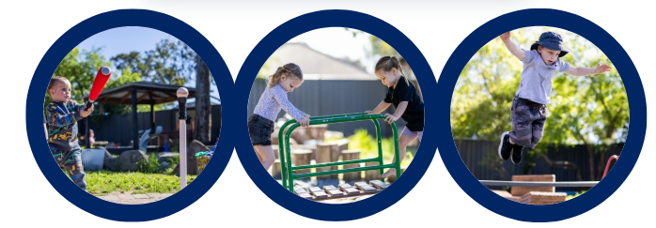

**Reflection on the environmental checklist**

|  |
| --- |
| **What opportunities/strengths were identified during this self-assessment?** |
| **What challenges were identified during this self-assessment?** |
| **Any additional notes** |

**Step 3: Overcoming Challenges**

The following table provides possible solutions to challenges you may have identified in the checklist. To help you navigate through the table, sections A-C align with the **Environmental Checklist**. Section D addresses additional considerations.

|  |  |  |  |
| --- | --- | --- | --- |
| **SECTION A: LAYOUT OF THE ENVIRONMENT AND SUPERVISION** | | | |
| **Consideration** | **Suggestions** | | |
| Outdoor space (e.g., limited, or large space, layout concerns, access to the outdoors) | General tips:   * Review the following resources for handy tips on modifying outdoor spaces to ensure suitability:   + [KU Mayfield Preschool case study](https://goodforkids.nsw.gov.au/media/3404/ku-mayfield-case-study.pdf)   + [Honeybee Preschool case study](https://goodforkids.nsw.gov.au/media/3405/honeybee-preschool-warners-bay-case-study.pdf)   + [Create The Perfect Play Space](https://www.acecqa.gov.au/sites/default/files/2021-01/CreateThePerfectPlaySpace.PDF) resource (acecqa.gov.au)   Layout concerns:   * Modify the outdoor space to ensure specific areas can be supervised from one vantage point. * Barricade areas that are difficult to supervise.   Access to the outdoors:   * Remove any barriers restricting access between the indoor and outdoor environments. * Provide verbal cues or play a certain song at the start of the indoor-outdoor free play session. * Consider if the door to the outdoor environment can be left open during the indoor-outdoor free play session.   Optimising use of space:   * Rearrange equipment to open up more space in the outdoor environment. * Include moveable items and open-ended materials. * Rotate the selection of outdoor equipment/resources regularly. * Create a space for small group play and socialising by zoning an area with bamboo poles, plants, or large stones, or use pots to surround a secret garden. | | |
| Supervision/Staffing | * Rotate Educators supervising outdoor play depending on the number of children outside. * Limit flow between the indoor and outdoor spaces to a single access point. * Strategically place mirrors and use glass doors or windows for optimal supervision. * Modify the area so Educators can supervise specific sections from one vantage point. * Check rosters and scheduling of breaks to see if any changes are required to maintain ratios and make supervising easier. * Bring the indoor equipment outside. * Review the following resources for more handy tips:   + [KU Mayfield Preschool case study](https://goodforkids.nsw.gov.au/media/3404/ku-mayfield-case-study.pdf)   + [Uniting Preschool Adamstown Heights case study](https://goodforkids.nsw.gov.au/media/3403/uniting-preschool-adamstown-heights-case-study.pdf) | | |
| **SECTION B: WEATHER AND SUN SAFETY** | | | |
| **Consideration** | **Suggestions** | | |
| Weather | General Tips for Various Weather Conditions:   * Develop a standard procedure for families to send extra clothing/wet weather gear with children. * Prompt families to pack suitable clothing in regular communications & service noticeboards. * Purchase waterproof onesies, raincoats and/or children’s gumboots in bulk and have these on hand at the service. * Utilise undercover spaces. * Allow for flexibility within the daily program to allow for adjustments based on the weather. * Implement indoor-outdoor play one room at a time in bad weather. * Consider long term solutions such as building shelters, increasing green space/ shade, shade cloths etc. * Think about what fun activities and resources could be available for children under different weather conditions (e.g., watering cans and floating objects such as toy or paper boats on rainy days). See the windy day, rainy day and sunny day “prop boxes” ideas in [CreateThePerfectPlaySpace.PDF (acecqa.gov.au)](https://www.acecqa.gov.au/sites/default/files/2021-01/CreateThePerfectPlaySpace.PDF) (page 23). * View the [Get Outside and Get Active in Any Weather](https://goodforkids.nsw.gov.au/media/3343/outdoor-play-in-any-weather-munch-move.pdf) resource for more ideas.   Hot Weather & Sun Safety:   * Enable children to apply their own sunscreen. * Display posters or signs prompting families to apply sunscreen at drop off. * Set up an additional sunscreen station in the outdoor environment. * Incorporate additional times to apply sunscreen. * Set up water stations outside. * Consider if there are any shaded areas that are not being used to their full   potential. Are there objects currently in your shaded areas such as pot plants or shelves that could be moved? Can popular movable equipment (e.g., portable forts, climbing apparatus) be placed under the shade on hot days?   * Review the following resources for some important considerations:   + [Adapting the outdoor area for heat and UV](https://goodforkids.nsw.gov.au/media/3344/adapting-the-outdoors-for-heat-and-uv-munch-move.pdf)   + [SunSmart Early Childhood Resources](https://www.sunsmart.com.au/advice-for/schools-early-childhood/education-resources/early-childhood-resources)   + [Cancer Council SA – Resources for Early childhood centres](https://www.cancersa.org.au/prevention/sunsmart/sunsmart-program/early-childhood-centres/resources-early-childhood/#policy-documents)   + [Shade & Early Childhood (cancercouncil.com.au)](https://www.cancercouncil.com.au/cancer-prevention/sun-protection/preventing-skin-cancer/shade/shade-in-childcare-centres/) | | |
| **SECTION C: EQUIPMENT** | | | |
| **Consideration** | **Suggestions** | | |
| Placement of toys or equipment | * Observe children play and see how they engage with equipment and resources. * Encourage children to help set up the play area. * Place shovels, wheelbarrows, and rakes near sandpits or digging patches. * Place cooking equipment near sandpits or water play areas. * Create an obstacle course or treasure hunt. * Ensure the children can easily access the toys and equipment. | | |
| Lack of equipment  *Friendly tip: You don’t need a lot of equipment* 😊 | * Create your own equipment using recycled materials. * Provide natural resources such as leaves, bark, pinecones, pebbles, shells, soil sand, clay, and water. * Work with families and community to source donations. Family/community volunteers may also have skills to construct equipment or outdoor spaces. * Include everyday items from around the home. * Review the following resources for some handy tips:   + [KU Mayfield Preschool case study](https://goodforkids.nsw.gov.au/media/3404/ku-mayfield-case-study.pdf)   + [Honeybee Preschool case study](https://goodforkids.nsw.gov.au/media/3405/honeybee-preschool-warners-bay-case-study.pdf)   + Equipment to Enhance Active Play for[Preschoolers](https://goodforkids.nsw.gov.au/media/3236/equipment-to-enhance-active-play-preschoolers-munch-move.pdf) / [Infants & Toddlers](https://goodforkids.nsw.gov.au/media/3235/equipment-to-enhance-active-play-infants-munch-move.pdf) | | |
| **SECTION D: OTHER CONSIDERATIONS** | | | |
| **Consideration** | | **Suggestions** |
| Meeting individual child requirements (e.g., children with special needs, different age groups) | | * Trial indoor-outdoor play for all ages, or section off the room during indoor-outdoor play time (perhaps while the younger children are resting or having a separate planned learning experience). * Include resources and design environments that reflect children’s different ages, abilities and learning styles (e.g. resources and equipment are available at different levels of difficulty and in varying sizes). * Talk with families of children with special needs to determine any modifications that may be required. |
| Children’s play interests and engagement | | * Consider ideas to make the outdoor environment more engaging and fun, including thorough observations and discussion with children. What emerging interests and abilities can you see? * Relocate popular indoor activities to the outdoor environment. * Conduct an audit of the playground with the children to see what they would like to include in the outdoor space. An example of children involved in such audits is included in the [case study from Uniting Preschool Adamstown Heights.](https://goodforkids.nsw.gov.au/media/3403/uniting-preschool-adamstown-heights-case-study.pdf) * Include a variety of resources and games in the outdoor setting. |
| Families’ attitudes and engagement    *Fun Fact: The case studies describe how families were engaged in plans to increase outdoor play.* | | * Share your plans to increase outdoor play with your families. * Communicate the benefits of outdoor play to your families using the relevant family news snippets or your own communications. * Photograph your children enjoying the outdoor space and share learning stories, highlighting the benefits you are observing. * Invite families to a working bee to create an engaging and inviting outdoor space, or to donate any resources that may facilitate outdoor play. * Consult with your families if there are to be any policy changes. Aim to reflect the cultures of your families in any changes. |

|  |  |
| --- | --- |
| Perception children will miss out on indoor activities  *Note, Indoor-outdoor play is not designed to interfere or replace any planned intentional experiences and activities throughout the day* | * Set up traditional indoor activities in the outdoor environment (i.e., using portable equipment/resources). View the [Let’s Get Active Outside](https://goodforkids.nsw.gov.au/media/3345/encouraging-physical-activity-outside-munch-move.pdf) resource for ideas. * Create outdoor learning experiences which extend and compliment indoor learning experiences. * Similar to the indoor environment, you may like to create various sections/areas in the outdoor environment to support different types of play (e.g. different areas for quiet, manipulative, physical, nature, dramatic, art & craft, and sensory play). |
| Perception that school readiness is limited by “too much” outdoor free play.  *Note, Indoor-outdoor play is not designed to interfere or replace any planned intentional experiences and activities throughout the day*  References:   * Zhu, et al. Nature and success: Outdoor play is linked to school readiness. *Complementary Therapies in Clinical Practice*. 2024; 57: 101895. * Ginsburg. The importance of play in promoting healthy child development and maintaining strong parent-child bonds. *Pediatrics.* 2006; 119(1), 182-191. * Burdette, et al. Resurrecting free play in young children: Looking beyond fitness and fatness to attention, affiliation, and affect. *Archives of Pediatric and Adolescent Medicine. 2005;* 159(1), 46-50 | * Communicate the benefits of outdoor play to your families and staff using the family news snippets and newsletters.   Outdoor free play supports preschoolers' school readiness in several key ways:   * **Social Skills:** Children learn to interact with peers, share, negotiate, and resolve conflicts, which are essential for cooperative classroom environments. * **Emotional Regulation:** Free play helps kids manage their emotions and develop resilience by navigating various social and physical challenges. * **Cognitive or ‘Thinking’ Skills:** It stimulates creativity, problem-solving, and critical thinking as children explore, experiment, and imagine in an unstructured setting. * **Independence:** It encourages self-directed learning and decision-making, fostering a sense of autonomy and confidence. * **Language Development:** Interaction during free play promotes communication skills and vocabulary growth as children describe their actions and engage in conversations. * **Physical Development:** It enhances gross motor skills like running, jumping, and climbing, which are important for overall physical health and coordination. * A 2024 review of 10,682 preschoolers in the US, found that engaging in outdoor play was associated with multiple indicators of school readiness, i.e., early learning skills, self-regulation, social-emotional development, and flourishing. Engaging in outdoor play for more than 3 hours per day was associated with more beneficial outcomes. |

|  |  |
| --- | --- |
| Time to organise and adjust programme and routines | * Implement changes gradually rather than all at once. Make sure your action plan has realistic timeframes. * Modify your current program/schedule rather than making major adjustments or additions to the schedule. * Structure opportunities for outdoor free play in larger blocks to minimise transitions. * Restructure the order of activities on the daily routine to minimise the number of transitions. |
| Safety concerns  *Fun Fact: One of the GOGA case study Preschools (Honeybee Preschool) found accident rates actually decreased with indoor-outdoor free play.* | * Revise and update risk assessments. Take a [benefit-risk approach](https://theeducationhub.org.nz/promoting-childrens-risky-play-in-outdoor-learning-environments/). * Restrict access to any areas that cannot be supervised effectively. * Check resources and equipment to ensure in good condition. * Show children how to safely use equipment. * Ensure the equipment at your service meets the requirements in the Australian playground equipment standards. * Discuss which strategies should be implemented with Educators at your service. Once a strategy is implemented, review to determine whether it is effective and make changes where required. * Review the following resources for some handy safety related tips:   + [Kidsafe NSW Playground Standards](https://www.kidsafensw.org/safety/playground-safety/playground-standards/)   + [Safe Outdoor Environments Checklist for Infants and Toddlers](https://www.virtuallabschool.org/infant-toddler/safe-environments/lesson-2/act/13846)   + [Risk Assessment and Management Safety Checklist (ACECQA)](https://view.officeapps.live.com/op/view.aspx?src=https%3A%2F%2Fwww.acecqa.gov.au%2Fsites%2Fdefault%2Ffiles%2F2021-08%2FRAMTemplate-DailyRiskChecklist.docx&wdOrigin=BROWSELINK)   + [ECE webinar: Exploring the potential of outdoor environments for children’s wellbeing and learning](https://theeducationhub.org.nz/ece-webinar-exploring-the-potential-of-outdoor-environments-for-childrens-wellbeing-and-learning/) |

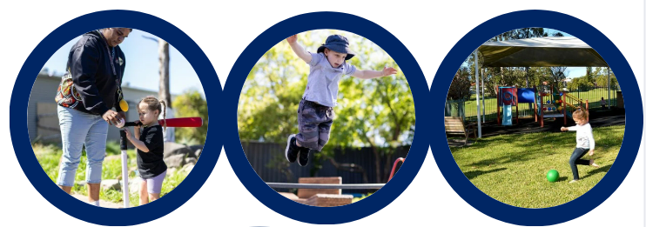

**Step 4: Making a Plan for Change**

**Action Plan**

**Making a plan for change can help keep your service on track. Having documentation of the processes undertaken to implement more indoor-outdoor free play can also be useful to include in your QIP.**

**Service name: Date:**

* + - 1. **Set an overall goal for full implementation of indoor-outdoor free play**.

We recommend basing your goal on how often and when you intend to be implementing indoor-outdoor free play sessions in your daily schedule. You may find it useful to refer to the Indoor Only Free Play Summary on page 4, to highlight potential opportunities for indoor-outdoor free play.

**Goal:** *(Include what, who is responsible, and by when)*

*Example Goals:*

* Educators in the Preschool Room operate an indoor-outdoor free play schedule at all existing free play sessions by the end of the year.
* Educators in the Kangaroo room offer indoor-outdoor free play for all free play sessions before 3pm, by Term 4.
  + - 1. **Set some actions that need to be taken to meet your goals** (pg 15)

We recommend you include actions to address the following:

* How you will **involve Educators** and other key stakeholders in deciding how to go about implementing indoor-outdoor free play.
* 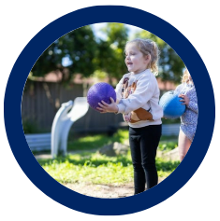Any specific tasks required to **overcome challenges** identified in the Environmental Checklist (including relevant suggestions from the Problem Solving Table).
* Any **processes required** as part of drafting, trialling and scheduling indoor outdoor free play.
* Any ongoing **communication strategies** e.g. with families, staff, children, etc.

Need some inspiration? Example actions and strategies are included at the end of this document (pg 17-18).

**Step 4: Making a plan for Change**

**Step 4: Making a plan**

| **Action** | **How will we do this?**  **(Strategy)** | **Who will do this?**  **(Responsibility)** | **By when?**  **(Timeframe)** | **Success measure** | **Resources required (equipment, staff, time etc.)** | **Status /**  **progress notes** |
| --- | --- | --- | --- | --- | --- | --- |
| **Example:**  *Communicate and consult with educators.* | * + 1. *Schedule in time for staff to watch the Good for Kids Information video*     2. *Schedule staff time to discuss the environmental checklist reflections, agree on our goals and plan for the next steps*. | *Jo* | *Term 2* | * 1. *All relevant staff are aware of initiative and objectives.*   2. *Our key actions are informed by critical reflection.* | *Staff time to meet, set a goal and develop some actions* |  |
|  |  |  |  |  |  |  |
|  |  |  |  |  |  |  |
|  |  |  |  |  |  |  |
|  |  |  |  |  |  |  |

*Example Actions & Strategies:*

**Step 4: Making a Plan for Change – Example Actions & Strategies**

Feel free to cut and paste and modify these for your action plan above.

|  |  |  |
| --- | --- | --- |
|  | **Example Action** | **Example Strategy (How will we do this)** |
| Getting started | Communicate and consult with Educators | Schedule in time to watch the information video with your staff. |
| Schedule staff time to discuss your reflections on the environmental checklist, agree on your goals and plan the next steps. |
| Share the prepared newsletters informing educators about your initiative to increase outdoor play. |
| Consult and communicate with families | Notify families of the new program by sharing the prepared family newsletter snippets or posts. |
| Request feedback from your families on the proposed changes to free play schedule |
| Take photos of children enjoying the outdoor space and share learning stories with families, highlighting the benefits |
| Identify your strengths and any possible challenges to implementing indoor-outdoor free play | Complete the environmental checklist reflections (pg 5-9) with staff and schedule time to discuss and identify any key actions required. |
| Send through your action plan & any questions to your Good for Kids support officer |
| Problem solving/ areas for improvement | Enhance supervision of the outdoor area | Complete a review of playground supervision visibility as part of the Environmental Checklist |
| Restructure your outdoor environment to allow supervision from one vantage point |
| Draft a new supervision procedure for indoor-outdoor play and discuss with staff. |
| Optimise the outdoor environment to support indoor-outdoor free play | Conduct a review of how children are using and moving equipment and resources and if necessary, use this to re-arrange the outdoor environment. |
| Move bookshelf away from doorway so that it is not blocking access to outdoor environment |
| Trial processes for cordoning off the area behind shed during indoor-outdoor free play |

**Step 4: Making a Plan for Change – Example Actions & Strategies**

|  |  |  |
| --- | --- | --- |
|  | **Example Action** | **Example Strategy (How will we do this)** |
| Problem solving/ areas for improvement | Implement indoor-outdoor free play under various weather conditions | Communicate a standard procedure for families to send extra clothing/wet weather gear with children. |
| Update procedures to ensure outdoor play is supported in most weather conditions (whilst ensuring child safety). |
| Modify timing of daily programs in adverse weather e.g. re-schedule outdoor free play to the afternoon if the morning weather is unfavourable |
| Install a shade cloth in the outdoor space |
| Create and provide access to prop boxes with items that children can engage with for different types of weather including hot, rainy, and windy conditions |
| Review and update sunscreen application procedures to account for additional time outside |
| Make the outdoor environment more enticing for the children | Move indoor activities to the outdoor environment. |
| Have a discussion with the children in the preschool room to determine what they would like to include in the outdoor space. |
| Role model and maintain a positive attitude to outdoor play. |
| Collect additional resources to use in the outdoor environment | Ask families or local organisations to donate materials/resources to enhance the outdoor space. |
| Schedule a time to plan, create and place additional resources outside |
| Embedding into service operations | Update policies and procedures to support the implementation of indoor-outdoor free play | Update the daily routine to show the change to indoor-outdoor free play at the 10:00am – 10:30am session. |
| Update the physical activity policy to incorporate regular indoor-outdoor free play using the provided policy templates |
| Report in Quality Improvement Planning. | Report the key actions we identified and the outcomes in our QIP. |



Please do not hesitate to get in touch with the Good for Kids team if you have any questions.



**Contact details:**

Email: hnelhd-goodforkids@health.nsw.gov.au