FMS game template

Plan a game that you could run at your service to intentionally teach fundamental movement skills. Include at least 2 fundamental movement skills in the game. The game should run for approx. 10 minutes and use equipment that is available within the service.
Fill in the template on page 2 to describe your game, including:
- FMS practiced in the game
- Game instructions
- Equipment required
- Modifications (how can the game be made easier or harder)
- Reflections (complete after you run the game at your service)
- Diagram (optional)
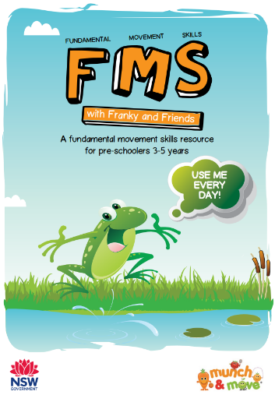

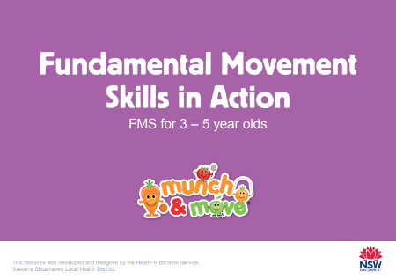
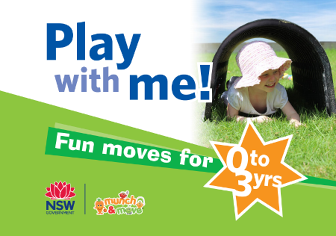
Refer to the following resources if you need some inspiration:
Play With Me! Fun Moves for 0-3s
FMS in Action: FMS for 3-5s
FMS with Franky & Friends

If you would like to share your FMS game with other webinar participants, please save or scan your completed game plan and send it to HNELHD-GoodForKids@health.nsw.gov.au. We will then compile the game ideas and circulate them to all participants.

FMS practiced | Game instructions | Equipment required | Modifications  (how can the game be made easier or harder) | Reflections  (complete after you run the game at your service)
Locomotor FMS
- Jump
- Leap
- Skip
- Hop
- Side slide
- Run
- Gallop

Manipulative FMS
- Catch
- Underarm throw
- Overarm throw
- Kick
- Stationary dribble
- Striking a stationary ball

Diagram (optional)

