Munch & Move Policy Review

Does your service have the following policies? Do the policies contain the following elements recommended by Munch & Move?
Please tick the checkboxes relevant to your service and for the elements that are present in your policies.
Service Name: _____________________________________________________________________
Breastfeeding policy  [Services with children aged 0-12 months only] | ☐ Yes  ☐ No | ☐ Families are informed that the service provider and educators support breastfeeding when the families first make contact with the service provider (or during orientation).  ☐ Families are asked about breastfeeding at the time of enrolment.  ☐ Services develop a documented feeding plan for breastfed infants.  ☐ Services provide a supportive physical environment for mothers who want to breastfeed.
Nutrition policy | ☐ Yes  ☐ No | ☐ Strategies are in place to ensure that food provided by families in lunchboxes is consistent with the Australian Dietary Guidelines [Services who do not provide main meals only].  ☐ Food provided by the service is consistent with the Australian Dietary Guidelines [Services where food (meals/snacks) are provided only].  ☐ Strategies are in place to ensure food isn’t used as a reward or incentive for children.  ☐ Educators role model healthy food and drink choices.
Physical activity policy | ☐ Yes  ☐ No | ☐ Reference to the Australian 24-Hour Movement Guidelines for the Early Years (birth to 5 years).  ☐ Physical activity is embedded in the daily program through spontaneous and intentionally planned active play that is both child initiated and educator led.  ☐ Educators actively role model to children appropriate physical activity behaviours.
Small screen recreation policy | ☐ Yes  ☐ No | ☐ Reference to the Australian 24-Hour Movement Guidelines for the Early Years (birth to 5 years) (Sedentary Behaviour Recommendations).  ☐ Not using screen time as a reward or to manage challenging behaviours.  ☐ Educators are encouraged to role model appropriate screen behaviours to the children.

Please return the checklist to your support officer or Good For Kids: HNELHD-GoodforKids@health.nsw.gov.au
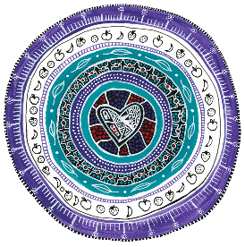
Worimi Artist, Lara Went
“The heart of a child”

