(Insert early childhood education and care service name)
Nutrition Policy (Procedure) – Encouraging Healthy Eating and Supporting Breastfeeding

Note: The following information has been provided to assist early childhood education and care services to develop their own nutrition policy (procedure). Tailor the information in this sample policy (procedure) to your particular service – delete sections that are not relevant to your service and add additional points that reflect your practice. Involve staff and families in the policy (procedure) development and review process. Ensure that the final policy (procedure) is on display and accessible to all staff and families.

Rationale
Early childhood education and care (ECEC) services are required by legislation to ensure the provision of healthy foods and drinks that meet the requirements for children according to the Australian Dietary Guidelines. It is essential that ECEC services partner with families to provide education about nutrition, and promote healthy eating habits for young children to positively influence their health and wellbeing. Dietary and healthy eating habits formed in the early years are shown to continue into adulthood and can reduce the risk factors associated with adult chronic conditions such as obesity, type 2 diabetes and cardiovascular disease.

Service Commitment
(Insert early childhood education and care service name) recognises the importance of healthy eating for the growth, development and wellbeing of young children and is committed to promoting and supporting healthy food and drink choices for children in our care. This policy (procedure) affirms our position on the provision of healthy food and drink while children are in our care and the promotion and education of healthy choices for optimum nutrition.
Our service is committed to implementing and embedding the healthy eating key messages outlined in the NSW Health’s Munch & Move program into our curriculum and to support the National Healthy Eating Guidelines for Early Childhood Settings outlined in the Get Up & Grow resources.
Further, (insert early childhood education and care service name) recognises the importance of supporting families in providing healthy food and drink to their children. It is acknowledged that the ECEC service has an important role in encouraging, supporting and educating families in healthy eating.

Relevant Legislation
National Quality Framework

Early Childhood Education and Care Services National Regulations
Section 3(2)(a); 167– Protection of children from harm or hazards
Regulation 77 – Health, hygiene and safe food practices
Regulation 78 – Food and beverages
Regulation 79 – Service providing food and beverages
Regulation 80 – Weekly menu
Regulation 90 and 91 – Medical conditions

National Quality Standard
Element 1.1.3
Standard 2.1 – Each child’s health and physical activity is supported and promoted
Elements 2.1.1,2.1.2, 2.1.3
Element 2.2.1
Element 3.2.3
Element 4.2.2
Standard 5.1 Respectful and equitable relationships are maintained with each child.
Element 5.1.2
Standard 6.1 – Respectful relationships with families are developed and maintained and families are supported in their parenting role.
Element 6.1.2, 6.1.3
Element 7.1.2
Element 7.2.1

Early Years Learning Framework
Learning Outcome 1 – Children feel safe, secure and supported.
Learning Outcome 3 – Children have a strong sense of wellbeing.
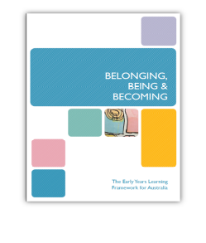
Learning Outcome 4 – Children are confident and involved learners.
Principles – Secure, respectful, reciprocal relationships; Respect for diversity; Partnerships with families; Ongoing learning and reflective practice.
Practice – Holistic approaches; Intentional teaching; Learning environments.

Legal Requirements
Our service recognises that the right to breastfeed is protected under federal and state legislation, and we will meet our legal obligations.

Healthy Eating Guidelines
- Exclusive breastfeeding is recommended, with positive support, for infants until around six months. Continued breastfeeding is recommended for at least 12 months – and longer if the mother and baby wish.
- If an infant is not breastfed, is partially breastfed, or if breastfeeding is discontinued, use an infant formula until 12 months of age.
- Introduce suitable solid foods at around six months.
- Make sure that food offered to children is appropriate to the child’s age and development, and includes a wide variety of nutritious foods consistent with the Australian Dietary Guidelines.
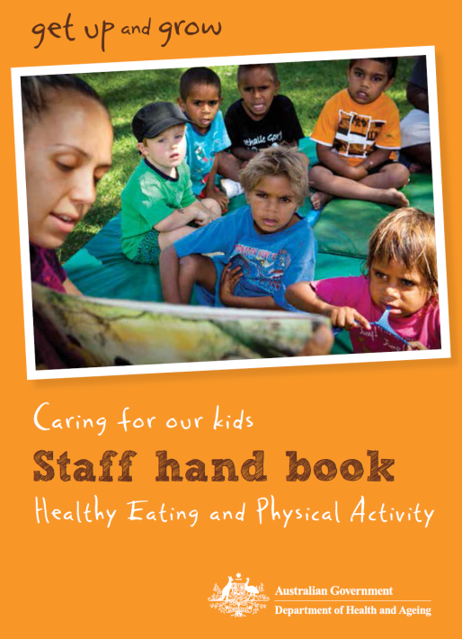
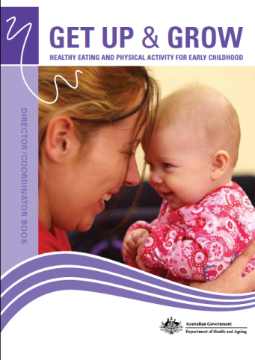
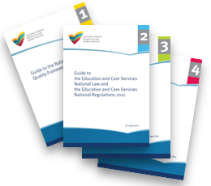
- Provide water in addition to age-appropriate milk drinks. Infants under the age of six months who are not exclusively breastfed can be offered cooled boiled water in addition to infant formula.
- Plan mealtimes to be positive, relaxed and social.
- Encourage children to try different food types and textures in a positive eating environment.
- Offer an appropriate amount of food, but allow children to decide themselves how much they will actually eat.
- Offer meals and snacks at regular and predictable intervals.
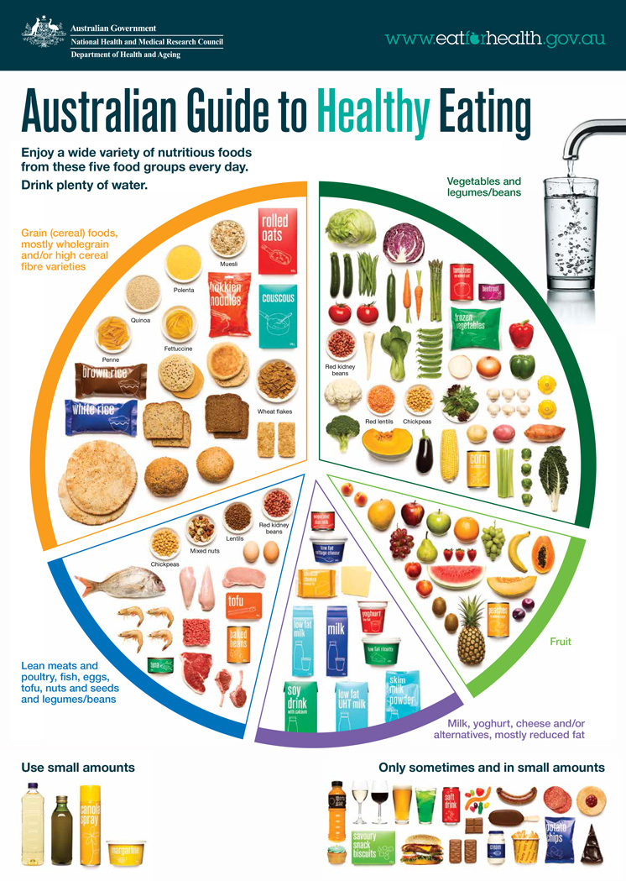
- Ensure that food is safely prepared for children to eat – from the preparation stages to consumption.

Other Relevant Legislation
Food Act 2003 (NSW) – www.legislation.nsw.gov.au/#/view/act/2003/43, accessed 5/12/2016
Food Regulation 2015 – www.legislation.nsw.gov.au/#/view/regulation/2015/622, accessed 1/12/2016

Food Standards Code including:
Standard 3.2.2 – Food Safety Practices and General Requirements
Standard 3.2.3 – Food Premises and Equipment
Standard 3.2.1 – Food Safety Programs for Food Service to Vulnerable Persons – www.foodstandards.gov.au/code/Pages/default.aspx, accessed 5/12/2016

Key Resources
- NSW Health Munch & Move program resources available on the Healthy Kids website www.healthykids.nsw.gov.au
- Caring for Children: Birth to 5 years (Food, Nutrition and Learning Experiences), NSW Ministry of Health, 2014
- Infant Feeding Guidelines, 2012, www.eatforhealth.gov.au
- Australian Dietary Guidelines, 2013, www.eatforhealth.gov.au
- Staying Healthy: Preventing infectious diseases in early childhood education and care services (5th edition), 2013.
- NSW Food Authority information for children’s services www.foodauthority.nsw.gov.au/retail/childrens-services
- Food Standards Australia, for information on food safety and food handling www.foodstandards.gov.au.
- Anaphylaxis Australia www.allergyfacts.org.au
- Staying Healthy: Preventing infectious diseases in early childhood education and care services (5th edition), 2013.
This policy (procedure) aims to:
- Encourage and support breastfeeding and appropriate introduction of solid foods.
- Promote healthy food and drinks based on the Australian Dietary Guidelines and the Australian Guide to Healthy Eating.
- Provide age appropriate food and drinks to children that have been stored, prepared and served in a safe and hygienic manner and to promote hygienic food practices.
- Provide a positive eating environment that is relaxed and social, and reflects cultural and family values.
- Promote lifelong learning for children, early childhood educators and families about healthy food and drink choices including trying new healthy foods.
- Encourage communication with families about the provision of appropriate healthy food and drinks for children while they are attending the service.

Our strategies to implementing this policy (procedure) include:
1. Encourage and support breastfeeding and appropriate introduction of solid foods
- Encourage and support breastfeeding by:
  - Informing families that the service supports breastfeeding at first contact or at orientation, and asking if families would like to continue offering their infant breastmilk while in care.
  - Asking families about breastfeeding at the time of enrolment.
  - Providing a suitable place within the service where mothers can breastfeed their infants or express breastmilk. This place may include an electrical outlet, comfortable chair, a change table and nearby access to hand washing facilities.
  - Providing refrigerator space for breastfeeding mothers to store their expressed breastmilk.
  - Supporting mothers to continue breastfeeding until infants are at least 12 months of age while offering appropriate complementary foods from around six months of age.
  - Developing a documented feeding plan for breastfed infants in consultation with family members. The plan will include arrangements for what the service should do if the service does not have enough expressed breastmilk to meet the infant’s needs.
  - Ensuring the safe handling of breastmilk and infant formula during transportation, storage, thawing, warming, preparation and bottle feeding.
  - Offering cooled pre-boiled water as an additional drink from around six months of age, in consultation with families.
  - Supporting the transition to infant formula where breastfeeding is discontinued before 12 months of age.
  - Always bottle feeding infants by holding the infant in a semi-upright position.
- Abide by the current national Infant Feeding Guidelines.
- Offer a variety of nutritious foods to infants from all of the food groups in line with the Australian Dietary Guidelines.
- Always supervise infants closely while drinking and eating.
- Ensure appropriate foods (type and texture) are introduced around six months of age including iron rich nutritious foods as infant’s first foods.
- Adjust the texture of foods offered between six and 12 months of age to match the infant’s developmental stage.
2. Promote healthy food and drinks based on the Australian Dietary Guidelines and the Australian Guide to Healthy Eating
Where food is provided by the service:
- Provide children with a wide variety of healthy and nutritious foods for meals and snacks including fruit and vegetables, wholegrain cereal products, dairy products, lean meats and alternatives.
- Plan and display the service menu (at least two weeks at a time) that is based on sound menu planning principles and meets the daily nutritional needs of children whilst in care (i.e. Caring for Children ‘Nutrition Checklist for Menu Planning’).
- Plan healthy snacks on the menu to complement what is served at mealtimes and ensure the snacks are substantial enough to meet the energy and nutrient needs of children.
- Vary the meals and snacks on the menu to keep children interested and to introduce children to a range of healthy food options.
Where food is brought from home:
- Provide information to families on the types of foods and drinks recommended for children and suitable for children’s lunchboxes (i.e. Caring for Children ‘Lunchbox Checklist for Food Brought from Home for 2 to 5 year olds’).
- Encourage children to eat the more nutritious foods provided in their lunchbox, such as sandwiches, vegetables, fruit, cheese and yoghurt, before eating any less nutritious food provided.
- Discourage the provision of highly processed snack foods high in fat, salt and sugar and low in essential nutrients in children’s lunchboxes. Examples of these foods include lollies, chocolates, sweet biscuits, muesli bars, breakfast bars, fruit filled bars, chips, high fat savoury crackers.
All services:
- Ensure water is readily available (both indoors and outdoors) for children to consume throughout the day.
- Be aware of children with food allergies, food intolerances and special dietary requirements and consult with families to develop individual management plans.
- Ensure young children do not have access to foods that may cause choking.
- Ensure all children remain seated while eating and drinking.
- Always supervise children while eating and drinking.
- Promote good oral health through learning experiences and daily ‘swish and swallow’ practice.
- Ensure any fundraising promotes healthy or active lifestyles and advocates for children’s wellbeing.
3. Provide age appropriate food and drinks to children that have been stored, prepared and served in a safe and hygienic manner to promote hygienic food practices
- Ensure gloves are worn or tongs are used by all staff handling ‘ready to eat’ foods.
- Children and staff wash and dry their hands (using soap, warm running water and single use or disposable towels) before handling food or eating meals and snacks.
- Food is stored and served at safe temperatures i.e. below 5ºC or above 60ºC.
- Use separate cutting boards for raw meat; utensils and hands are washed before touching other foods.
- Children are discouraged from handling other children’s food and utensils.
- Ensure staff handling food attend relevant training courses and share knowledge with all educators.
4. Provide a positive eating environment that is relaxed, social and reflects cultural and family values
- Ensure that educators sit with the children at meal and snack times to role model healthy food and drink choices and actively engage children in conversations about the food and drink provided.
- Recognise, nurture and celebrate the dietary differences of children from culturally and linguistically diverse backgrounds through strong partnerships with families and community.
- Create a relaxed atmosphere at mealtimes where children have enough time to eat and enjoy their food as well as enjoying the social interactions with educators and other children.
- Encourage older toddlers and preschool-aged children to help set and clear the table and serve their own food and drink – providing opportunities for them to develop independence, confidence and self-esteem.
- Respect each child’s appetite. If a child is not hungry or is satisfied, do not insist he/she eats.
- Be patient with messy or slow eaters.
- Encourage children to try different foods but do not force them to eat.
- Never use food as a reward or withhold food from children for behaviour management purposes.
5. Promote lifelong learning for children, early childhood education and care staff and families about healthy food and drink choices, including trying new healthy foods
- Foster awareness and understanding of healthy food and drink choices through daily discussions, displays, and intentionally planned or spontaneous related learning experiences throughout our service curriculum.
- Encourage and provide opportunities for all educators and staff members responsible for providing food and drinks to the children to participate in regular professional development opportunities to broaden their knowledge and understanding of children’s nutritional requirements.
- Provide opportunities for families to attend information sessions related to children’s nutrition and wellbeing.
6. Encourage communication with families about the provision of appropriate healthy food and drinks for children while they are attending the service
- Provide a copy of the Nutrition Policy to all families upon orientation at the service.
- Involve families in the review of this policy (procedure) annually.
- Request that details of any food allergies or intolerances or specific dietary requirements be provided to the service, and work in partnership with families to develop an appropriate resolution so that children’s individual dietary needs are met.
- Communicate regularly with families about food and nutrition related experiences within the service, including related professional development, and provide up to date information to assist families to provide healthy food choices at home.
- Communicate regularly with families and provide information and advice on appropriate food and drinks to be included in children’s lunchboxes. This information may be provided to families in a variety of ways including factsheets, newsletters, during orientation, information sessions and informal discussion.
Monitoring and Review
- Report on nutrition goals and achievements in the service’s Quality Improvement Plan (QIP) where appropriate, annual reports or management meetings.
- Include nutrition as a standing item on the staff meeting agenda.
- Review this policy (procedure) every (insert timeframe for review).
- Provide families with opportunities to contribute to the review and development of the service policy (procedure).

